2020 SURPLUS EQUIPMENT AND VEHICLE AUCTION
Wednesday, July 15, 2020
NEW LOCATION: South Middleton Township

PARTICIPANT INSTRUCTIONS

Thank you for participating in the 2020 Surplus Equipment and Vehicle Auction. Please read these directions carefully. It is important that you follow the directions so our auctioneer can accurately represent your items and get the best price possible. Completed spreadsheets are due in electronic format by June 5, 2020.

- All information is being gathered via excel spreadsheets, which were sent to you via email with these instructions.
- The first tab in the workbook is the cover page. It is critical that you complete this page in its entirety.
- The excel workbook contains individual sheets by category.
  - There are nine categories: bicycles, electronics, lawn & garden, office equipment and supplies, road equipment, tools, vehicles & heavy equipment, public safety, and miscellaneous.
  - To access a sheet (e.g. electronics), simply click on the tab at the bottom of the page marked for the category you want.
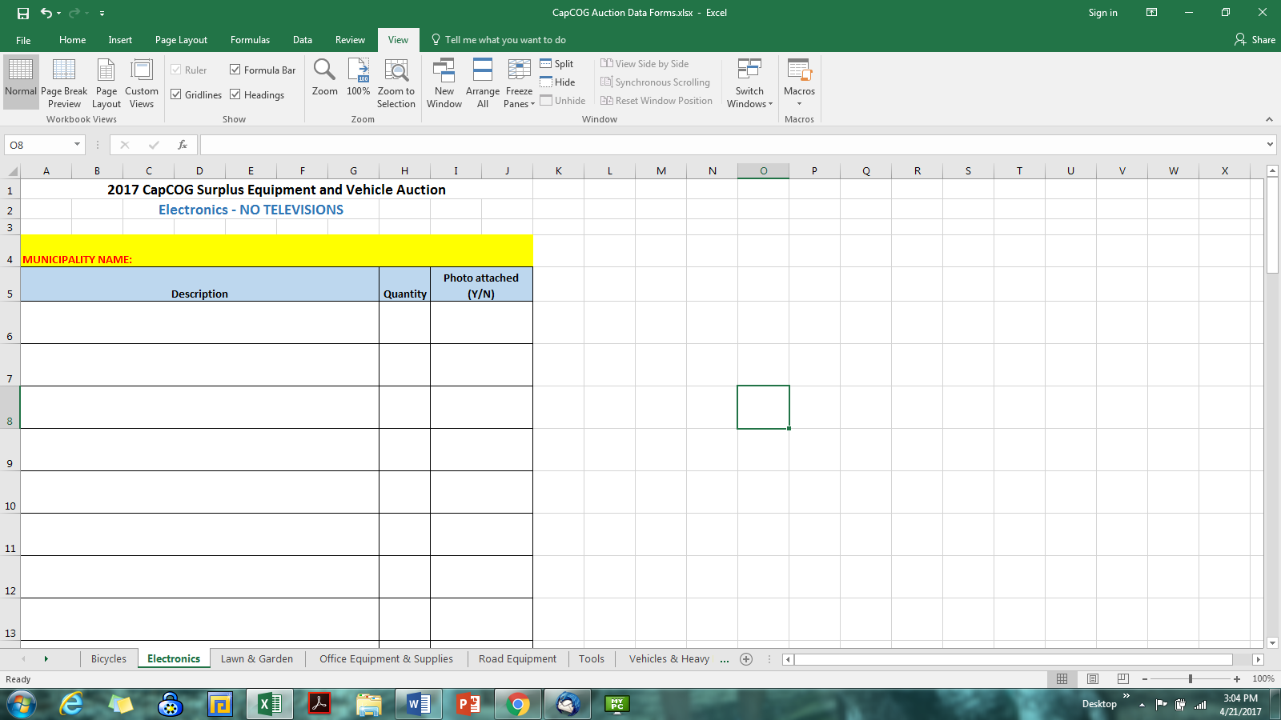

  - To see more tabs that aren’t visible, click the “…” at the right or left to scroll to see more tabs. If there are no “…” there are no more tabs.
  - Each spreadsheet is formatted for you to type in the items you wish to sell. Each spreadsheet is formatted for 9 items. Should you need more, simply type on the next available line.
  - Each spreadsheet has a yellow highlighted box where you MUST type your municipality/ organization name. Double click in the yellow box to type.
  - The spreadsheets are formatted so that you can click into a box and type. The text will wrap and adjust to fit.
  - If you do not have an item in a certain category, simply skip that spreadsheet.
  - Be sure to “save” your work frequently as you complete spreadsheets. Save the file with your Municipality/Organization Name – 2020 Auction Items (e.g., Hampden Township – 2020 Auction Items)

QUESTIONS? Email Rhonda at capcog@comcast.net or call 717.761.6211. Put AUCTION QUESTION in the subject line.

TERMS & CONDITIONS FOR 2020 AUCTION PARTICIPANTS

Read the terms and conditions below and return signed copy with your auction items via email to Rhonda Campbell capcog@comcast.net) by June 5, 2020.

- Auction participants will receive 80% of the sale price of all non-vehicle/large equipment items. Twenty percent of the gross proceeds will be withheld for administering the auction, including auctioneer commission, advertising, insurance, and administrative costs.
- Auction participants will receive 90% of the sale price on all vehicle/large equipment. Ten percent of the gross will be withheld for administering the auction, including auctioneer commission, advertising, insurance, and administrative costs.
- CapCOG and/or auctioneer cannot guarantee the sale of any item. A reserve (reasonable minimum acceptable price) may only be placed on the sale of vehicles. NOTE- Reserve Bids must be realistic and cannot exceed wholesale book price. The auctioneer highly recommends not placing reserves on vehicles unless absolutely necessary.
- Vehicles - The original title or a photocopy MUST be provided with a set of keys for vehicles when delivered to the auction site. Vehicles without this information will not be sold. Remove all decals from vehicles prior to submitting pictures.

IMPORTANT DATES

Friday, June 5, 2020 – Participation forms (in excel format) due to CapCOG.
- Describe your auction items in as much detail as possible.
- Include photos in .jpg format only. Photos can only be received if they are in jpeg. Do not scan photos and send as PDFs. Photos will be uploaded to the auction website. Pictures increase interest.
- Email forms to capcog@comcast.net by Friday, June 5, 2020 to ensure items are included in auction promotions.

Tuesday, July 14, 2020- Deliver merchandise to the South Middleton Township (more details to follow)
- All merchandise must be delivered between 8 am and 2 pm. If you cannot deliver during this timeframe, arrangements must be made in advance with the auctioneer.
- Check in with staff upon arrival prior to unloading.
- Vehicles should be delivered with their titles, unless prior arrangements are made with auctioneer.
- A forklift and operator will be available for unloading.
- After items are delivered, they may not be removed. This includes vehicles.
Wednesday, July 15, 2020 - All auction participants must have a representative on-site the day of the Auction. Auction starts promptly at 9:00 AM. Vehicles are auctioned at 1:00 PM.
- No items may be dropped off the morning of the auction without prior approval from the auctioneer.
- The representative is expected to answer questions regarding the condition of the items being bid.
- The representative must be authorized to transfer vehicle titles. Bring tools to remove license plates.
- Original titles must be available on the day of auction.
- A notary will be provided at the auction site at 12:00 PM for representatives to sign vehicle titles.

Thursday, July 16, 2020 – Remove unsold items from South Middleton Township by 12:00 PM.
- All auction participants are responsible for the disposal of unsold items by 12:00 PM on July 16.
- Any remaining items will subject the participant to trash removal fees and penalties.

Proceeds from the Auction - CapCOG will make payment to each participant, less 20%,(10% for vehicles and large equipment) based on items sold after funds and records from the auction are processed. Checks will be delivered via United States Postal Service. Itemized records of the auction will be included with your proceeds.

List your on-site contact person’s information below:
Auction Day Representative Name
Email | Phone (cell preferred)

__ I have read the above and agree to the terms and conditions
Printed Name | Signature | Date

