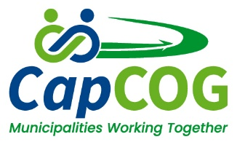
CapCOG BOARD OF DELEGATES - NO MEETING
September 15, 2025 - Picnic and Golf Tournament

There was no Board of Delegates meeting on September 15, 2025. The September meeting is replaced by the Picnic and Golf Tournament.

